**Group 3 – Villager Escape**

**Nauman Ijaz (24100311),**

**Ahmed Luqman (24100041)**

**Short Pitch:**

We designed this game as a horror/survival game, taking inspiration from simple indie games like Slenderman and Granny. The game requires the player to roam around and collect 5 keys scattered across the map in order to escape the village he is trapped in, all the while there is an old man (the antagonist) chasing you.

**Final Idea Complete Description and Highlights** (Screenshots)

The game incorporates a first-person view with you, the player roaming around with a flashlight. The map consists of around 5-6 buildings and an outdoor area, you must navigate through the map while avoiding the old man. If you are caught by him, you lose the game but if you manage to collect all 5 keys, you win and escape successfully.

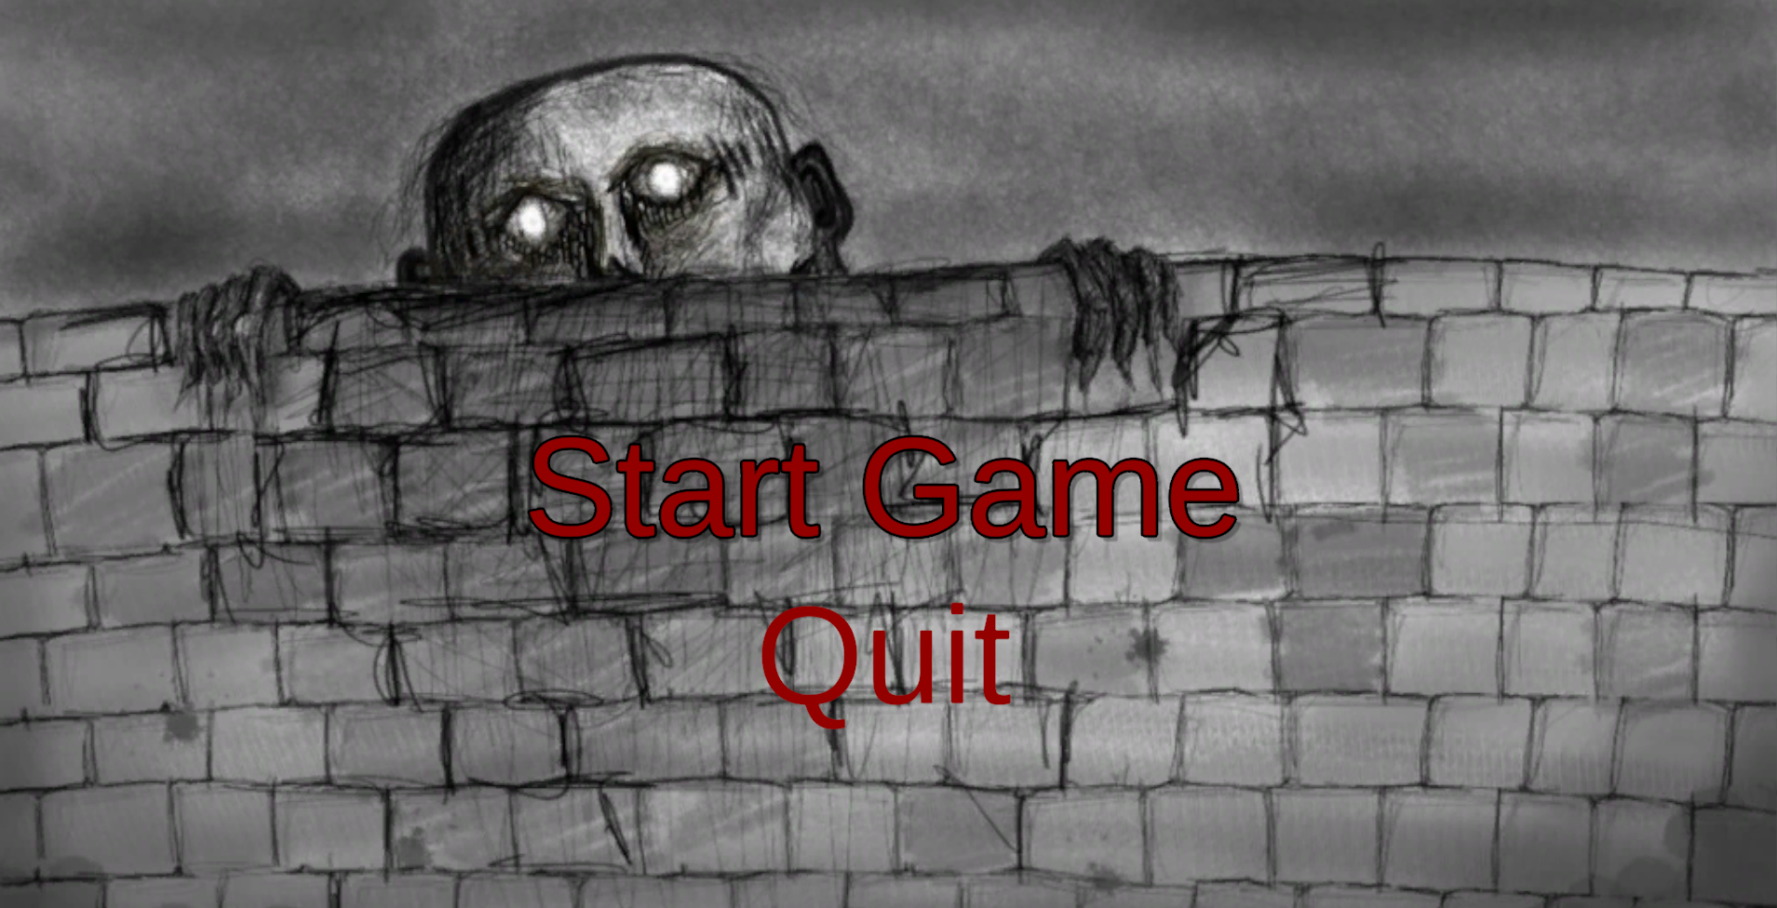

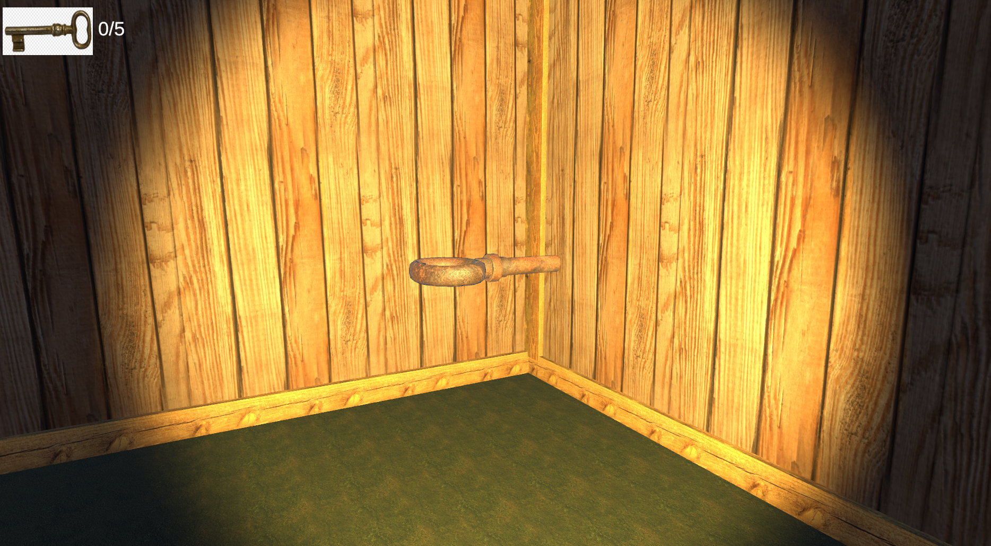

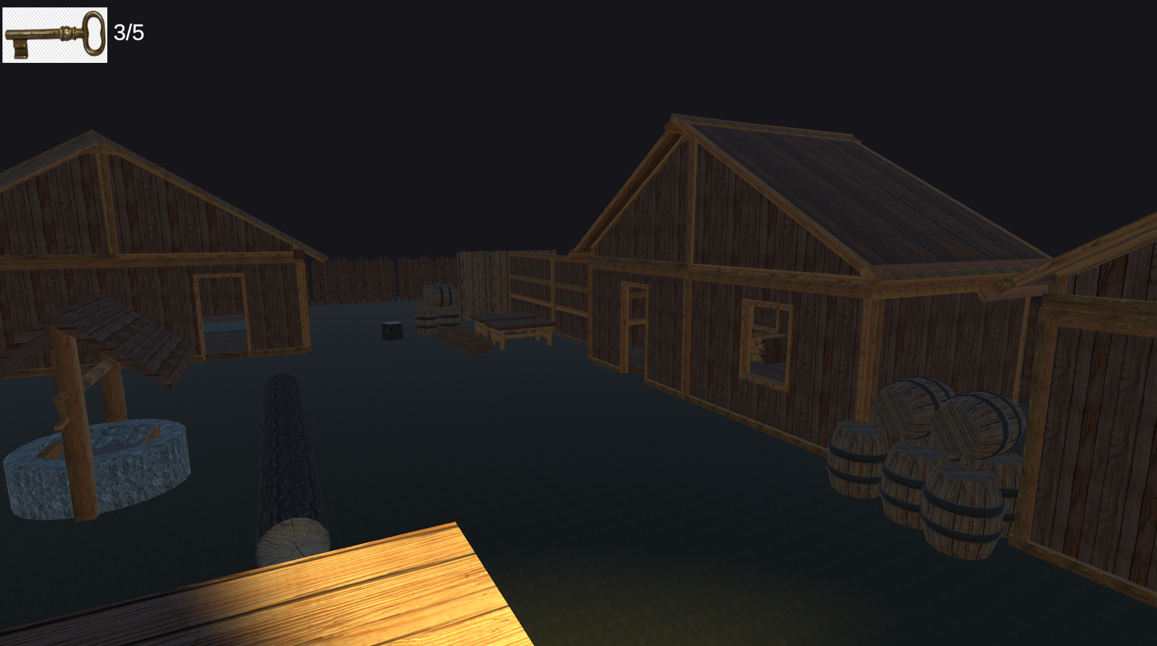

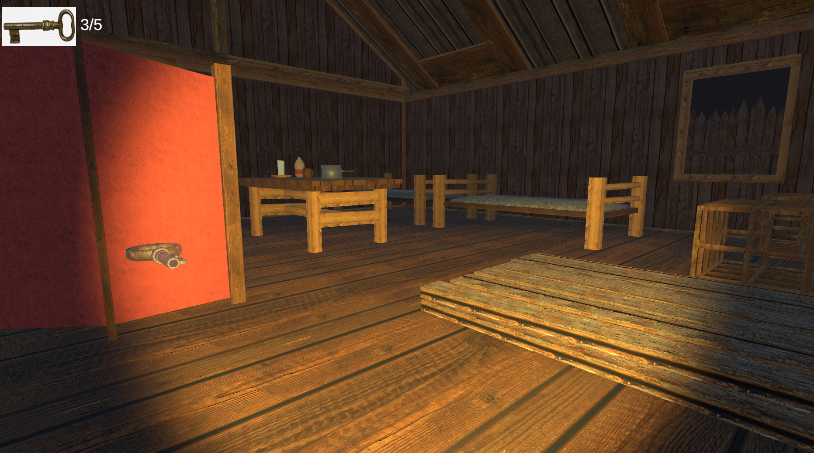

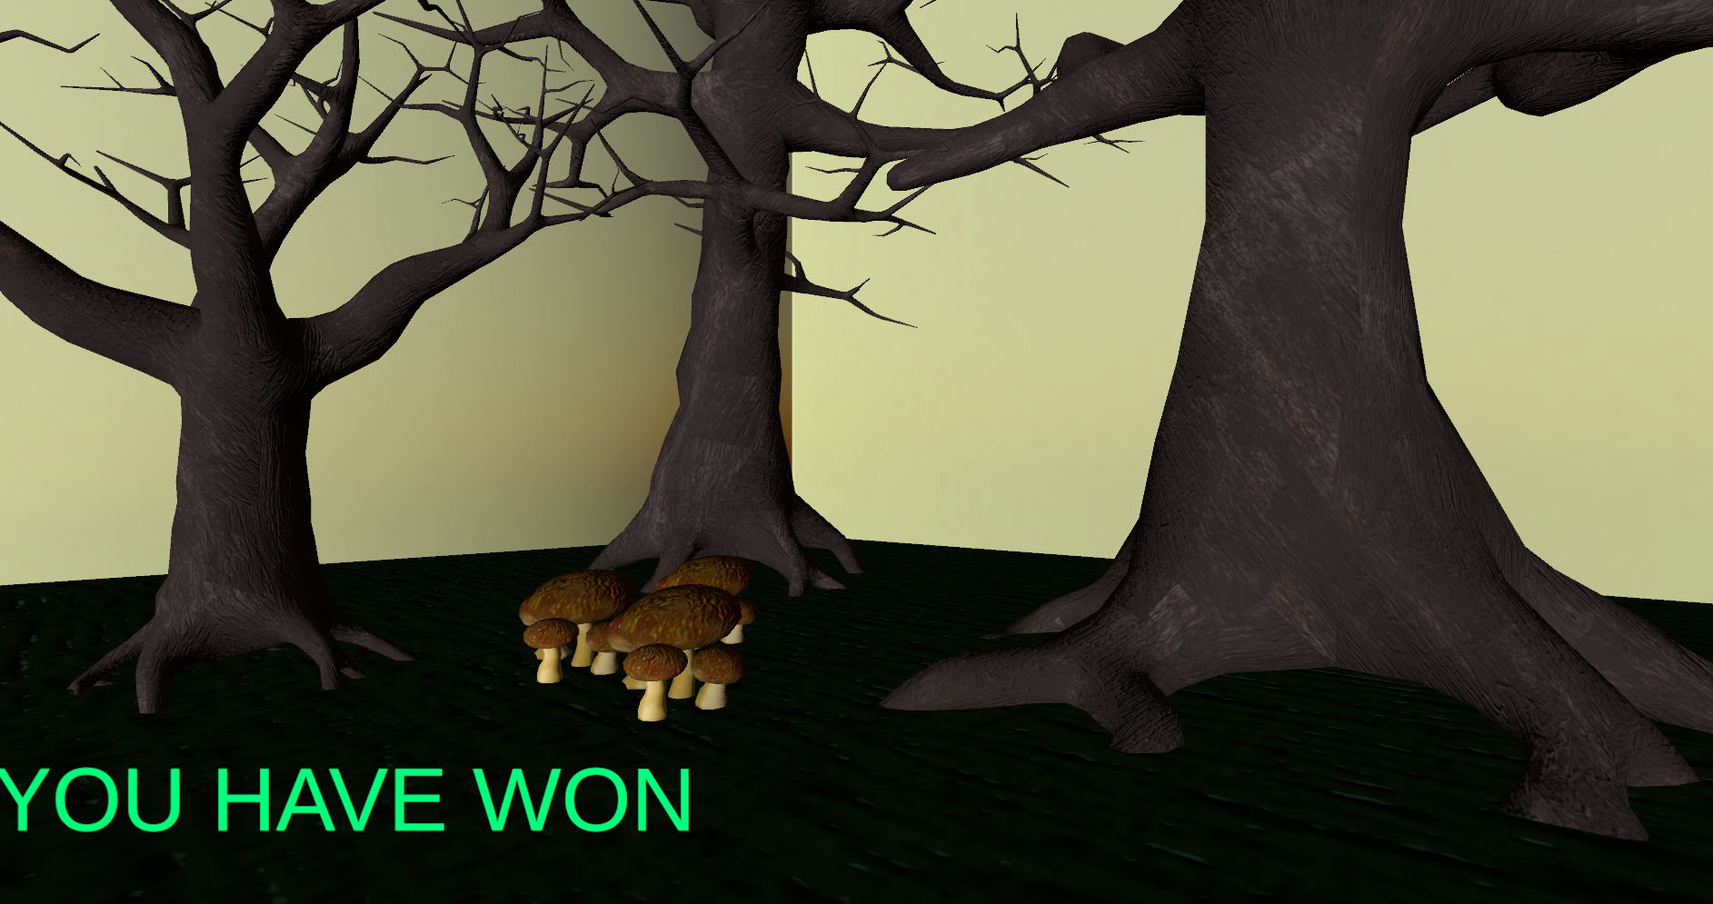

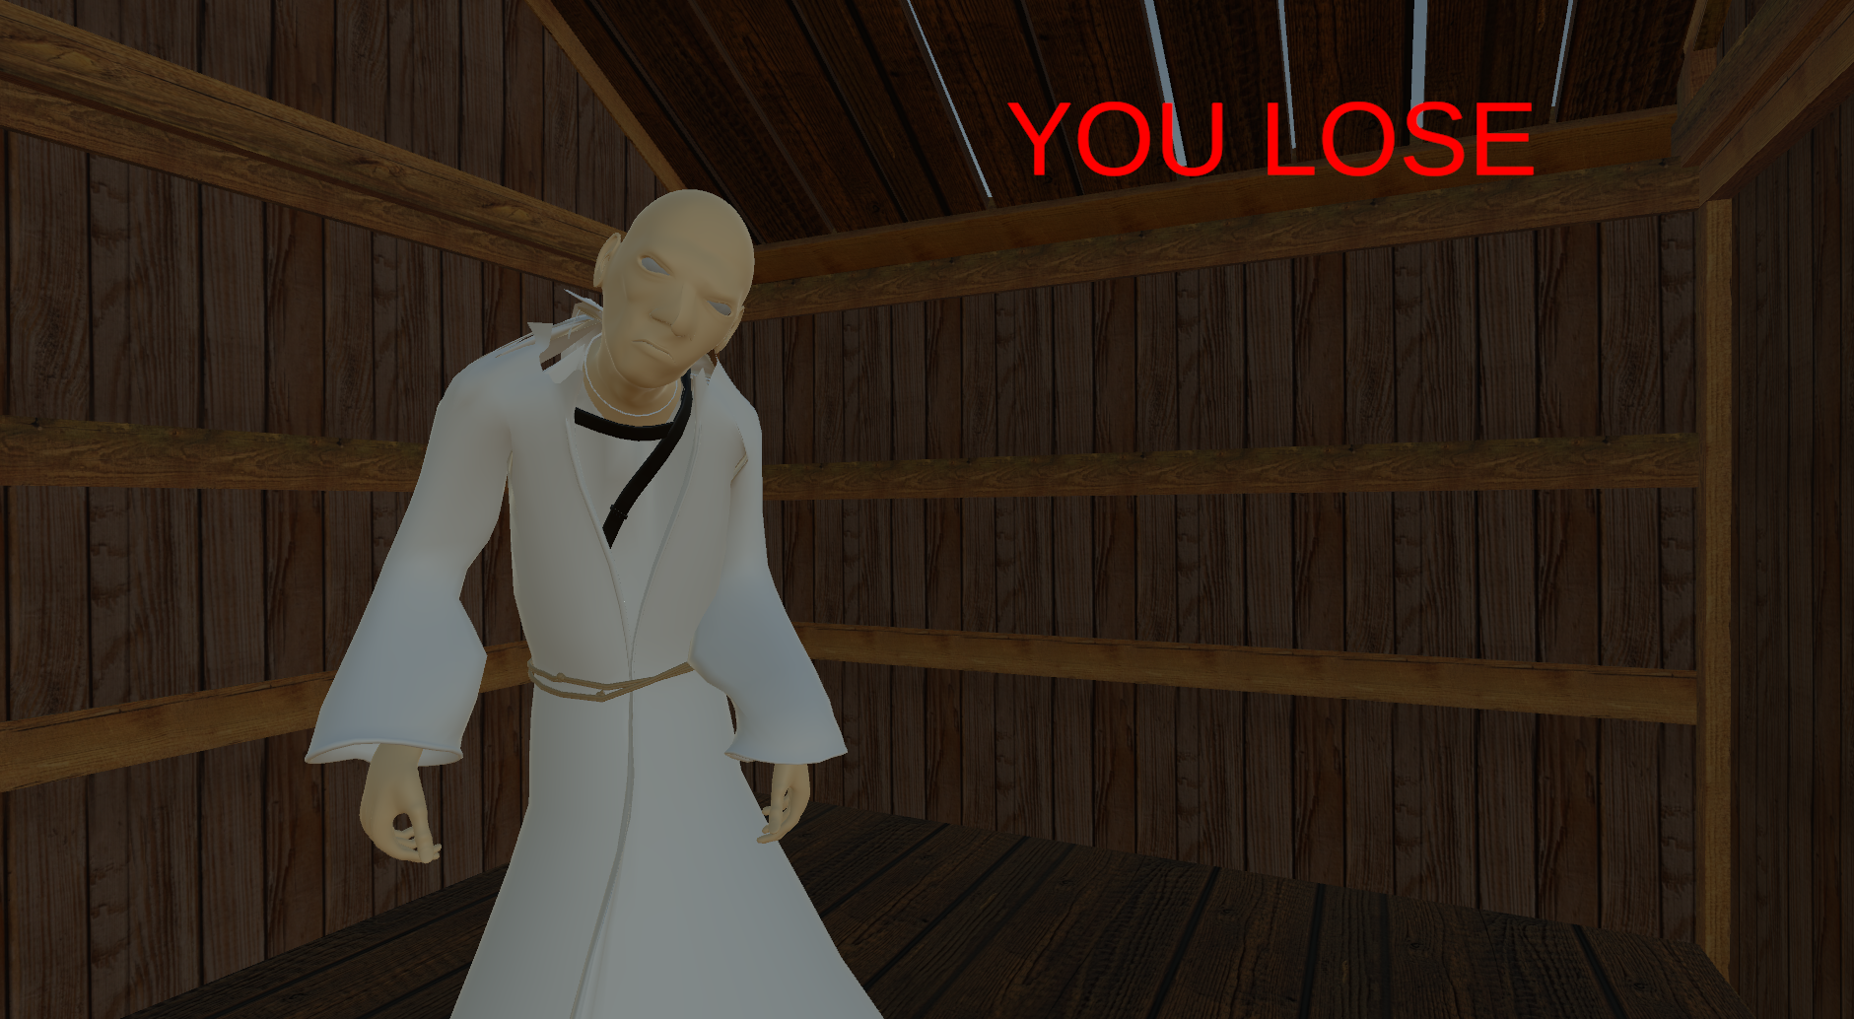

**Instructions** (and Controls if applicable)

Movement controls include WASD for Up, Left, Down, and Right. Additionally, pressing Left Shift while moving acts as a sprint function and pressing Space Bar acts as a jump command. Collect all 5 keys from different hidden locations around the map by traversing through buildings and objects while you try and not get captured by the old man.

**Features/Scenes and Process** (how they were created or made functional,

highlight any scripts and assets you used from online sources)

We hand drew the start screen backdrop. We used a medieval house pack asset pack from the Unity store to make most of the map, The asset contained decorations and wall segments, we constructed the houses using these assets and then added our own assets from Blender (Lamp, Painting, Football). The enemy was created by us in Blender too and we mapped animations on him from Mixamo. Our game consists of four different scenes, the main menu, the game itself, the winning result screen, and the losing screen.

Some script template inspirations were taken from multiple online sources which we used as a basis to implement our own versions. Furthermore, some decorations were imported from the unity assert store.

**Bugs and Improvements Required**

Our game is simple so we were able to fix almost all of our bugs except sometimes because of the pathing of the enemy he may get stuck in one corner of the map, in a window or door frame, however, this happens very rarely and if the player passes by him, he retargets properly.

For improvements, we could add an intermediatory screen between the start page and the game itself which would tell the player a little bit about the story and the objectives of the game.

**Contribution Statement**

**Start Screen:**

Nauman:

Created unity representation including functioning buttons and linking scenes.

Ahmed:

Created hand drawn backdrop

**Main Game / End Screen(s):**

Assets Division:

Nauman:

* Football (Blender)
* Painting (Blender)
* Made player model
* Wrote script for player and enemy (targeting and pathing)
* Made unity trigger events for both ending screens (“You Lose” and “You have Won” ending screen)
* Mapped animations to the model using Unity Animator Controller

Ahmed:

* Enemy model (Blender)
* Rusted Lamp (Blender)
* Made object collection API and Key-User Interface
* Created all game maps (spanning 3 scenes)
* Debugging in game specifications